NOTICE OF INDEPENDENT MAIL BALLOT ELECTION

§§ 1-13.5-510(2), 1-13.5-502, 1-13.5-1105(2)(d), C.R.S.

TO WHOM IT MAY CONCERN, and particularly, to the eligible electors of the proposed Reata Ridge Village Metropolitan District No. 2 (the “District”) in the Town of Parker, Douglas County, Colorado:

PUBLIC NOTICE is hereby given of a special election to be conducted on Tuesday, November 7, 2017, from 7:00 a.m. until 7:00 p.m. The purpose of the election is to submit to the eligible electors of the District the questions of organizing the District, electing directors, and voting upon certain ballot issues and ballot questions. This election is being conducted as an independent mail ballot election. Mail ballots will be mailed to eligible electors between 22 and 15 days prior to the election date.

At said election, the eligible electors of the District shall vote for Directors to serve the following terms of office on the Board of Directors of the District:

The names of persons nominated as Director to serve until they or their successors are elected and qualified at the next regular special district election in May 2018 (two seats to be voted upon) are:

There are no candidates for this office

The names of persons nominated as Director to serve until they or their successors are elected and qualified at the second regular special district election in May 2020 (three seats to be voted upon) are:

Mark DeRose
Molly Dixon
John Jagger

At said election, the eligible electors of the District shall vote on the following Ballot Issues certified by the proposed District:

Ballot Issue 5A (Operations, Administration and Maintenance Mill Levy – Ad Valorem Taxes)
Ballot Issue 5B (Capital Costs – Ad Valorem Taxes)
Ballot Issue 5C (Operations, Administration and Maintenance – Fees)
Ballot Issue 5D (Capital Costs – Fees)
Ballot Issue 5E (Multiple Fiscal Year Intergovernmental Agreement Mill Levy Question)
Ballot Issue 5F (Multiple Fiscal Year Private Agreement Mill Levy Question)
Ballot Issue 5G (De-TABOR)
Ballot Issue 5H (In-District Special Assessment Debt)
Ballot Issue 5I (Street Improvements)
Ballot Issue 5J (Parks and Recreation)
Ballot Issue 5K (Water)
Ballot Issue 5L (Sanitation/Storm Sewer)
Ballot Issue 5M (Transportation)
Ballot Issue 5N (Mosquito Control)
Ballot Issue 5O (Safety Protection)
Ballot Issue 5P (Fire Protection)
Ballot Issue 5Q (Television Relay and Translation)
Ballot Issue 5R (Security)
Ballot Issue 5S (Operations and Maintenance Debt)
Ballot Issue 5T (Refunding Debt)
Ballot Issue 5U (District Intergovernmental Agreements as Debt)
Ballot Issue 5V (District Private Agreements as Debt)
Ballot Issue 5W (Mortgage)
Ballot Issue 5X (Multiple Fiscal Year Intergovernmental Agreement)
Ballot Issue 5Y (Multiple Fiscal Year Private Agreement)

At said election, the eligible electors of the District shall vote on the following Ballot Questions certified by the proposed District:

Ballot Question 5Z (Organize District)
Ballot Question 5AA (Term Limit Elimination)
Ballot Question 5BB (Transportation Authorization)

Eligible electors may apply for mail ballots and return voted mail ballots in the office of the Designated Election Official at the following location:

Reata Ridge Village Metropolitan District No. 2
c/o White Bear Ankele Tanaka & Waldron
Attorneys at Law
2154 E. Commons Avenue, Suite 2000
Centennial, Colorado 80122
Tel: (303) 858-1800

The office of the Designated Election Official is open Monday through Friday, between the hours of 8:00 a.m. and 5:00 p.m., beginning at least 22 days prior to Election Day (October 16, 2017) and from 7:00 a.m. until 7:00 p.m. on Election Day (November 7, 2017).

The estimated mill levy projection for the first fiscal year after organization is 0 mills for operating and 50 mills for debt service.

The estimated fiscal year spending for the first year following organization is $42,340,000.

The boundaries of the proposed District are as attached hereto as Exhibit A.
By: | /s/ George M. Rowley
 | Designated Election Official

PUBLISHED IN: Douglas County News-Press
PUBLISHED ON: September 28, 2017

EXHIBIT A

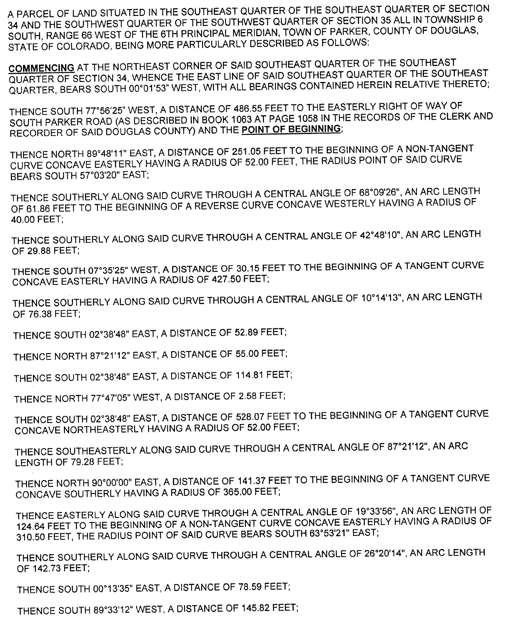
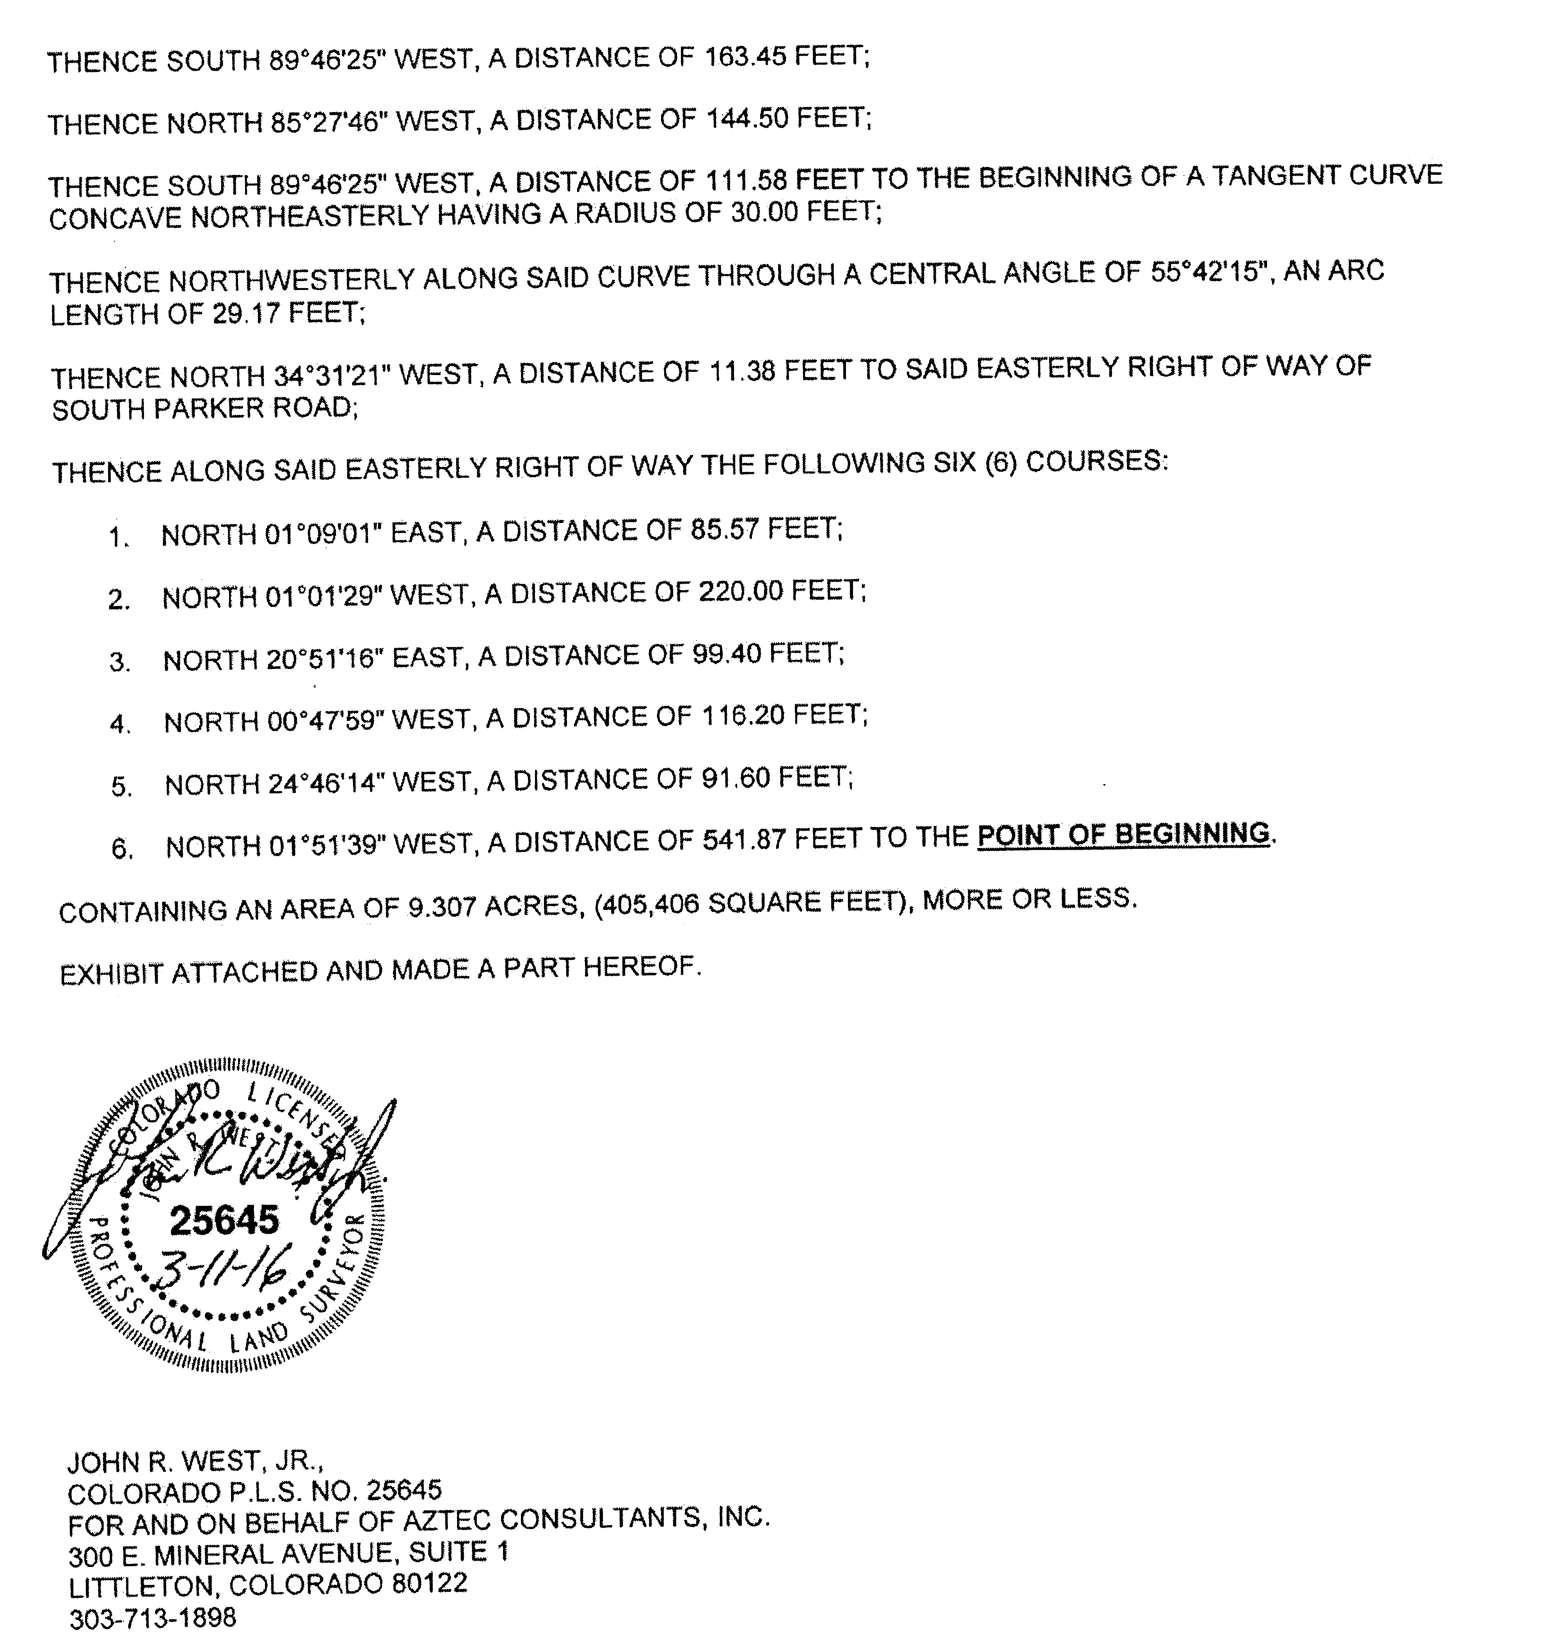

In addition to the foregoing, the following is also to be within the boundaries of Reata Ridge Village Metropolitan District No. 2:

Tract N, as shown on the Final Plat of Stroh Ranch Crossing Filing No. 1, recorded in the real property records of Douglas County, Colorado on June 3, 2016, at Reception Number 2016065224.

