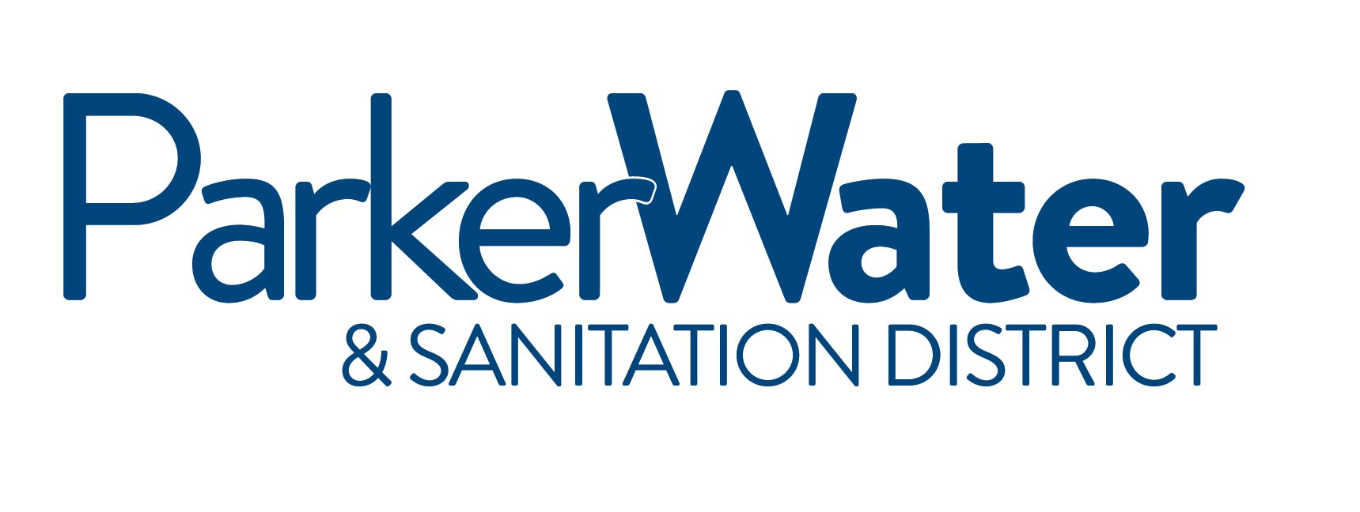
NOTICE IS HEREBY GIVEN
that the Board of Directors of the
PARKER WATER & SANITATION DISTRICT
of Douglas County, Colorado will hold a Regularly scheduled meeting at the

Parker Water & Sanitation District - North Water Reclamation Facility
18100 E. Woodman Drive, Parker, Colorado 80134

December 8, 2016
6:00PM

Members of the Public Who Wish to Speak during the Public Interest portion of the meeting must sign up.
The Sign-Up Sheet is located outside of the Conference Room.

The Board of Directors may take action on any of the agenda items as presented or modified prior to or during the meeting, and items necessary to effectuate the agenda items.

CALL TO ORDER
ROLL CALL
PLEDGE OF ALLEGIANCE

UNSCHEDULED ITEMS OF PUBLIC INTEREST This time is reserved for members of the public to make a presentation to the PWSD Board of Directors on items or issues that are not scheduled on the agenda. As a general practice, the Board will not discuss/debate these items, nor will the Board make any decisions on items presented during this time, rather will refer the items to staff for follow up. Comments are limited to four (4) minutes per speaker.
CHANGES AND ADDITIONS TO THE AGENDA
BOARD COMMENTS
LEADERSHIP TEAM COMMENTS
GENERAL LEGAL COUNSEL UPDATE

ITEMS FOR DISCUSSION AND ACTION BY THE BOARD
- APPROVAL OF MINUTES – November 10, 2016
- ACCOUNTS PAYABLE – November 1-30, 2016
- FINANCIALS – October 2016
- RESOLUTION 2017-01: CONSIDERATION OF 2016 WATER EFFICIENCY PLAN (1st Reading)
- WATER RESOURCE CENTRALIZATION PROJECT UPDATE
- RUETER-HESS RECREATION MASTER PLAN UPDATE
- RHR PROFILER PRESENTATION
- RESOLUTION 2016-14
EXECUTIVE SESSION: An executive session to consider the purchase, acquisition, lease, transfer or sale of real, personal or other property, pursuant to C.R.S. § 24-6-402(4)(a), and to determine positions relative to matters that may be subject to negotiations, develop a strategy for negotiations, and/or instruct negotiators, pursuant to C.R.S. § 24-6-402(4)(e). The following additional details are provided for informational purposes: the executive session will concern the acquisition of real property by the District for water projects.
ADJOURNMENT

