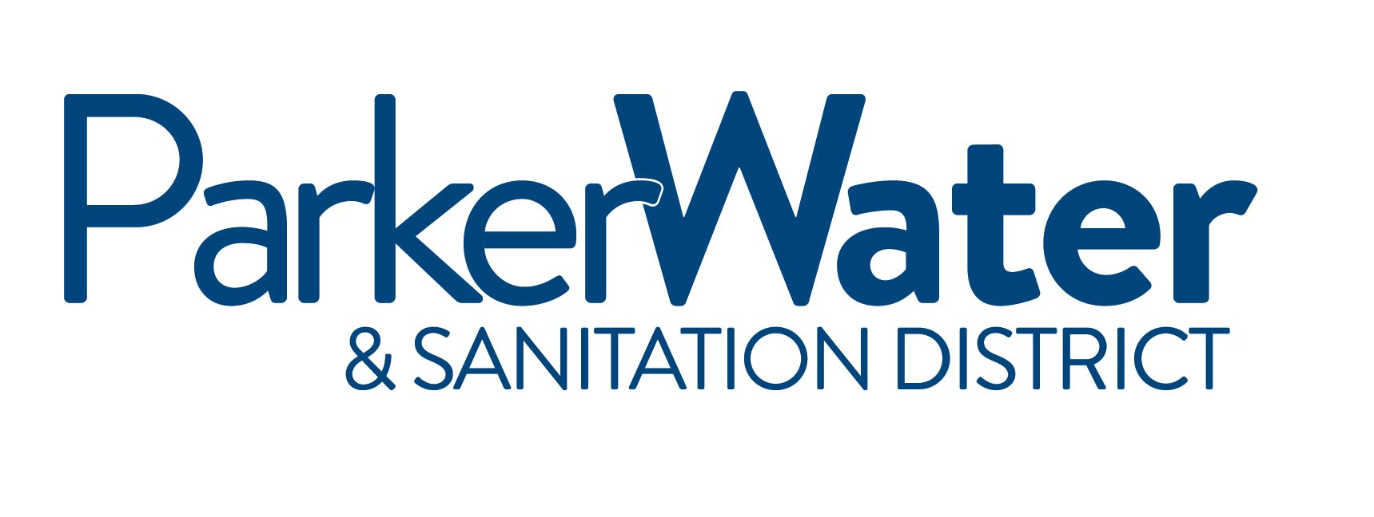

NOTICE IS HEREBY GIVEN
that the Board of Directors of the
PARKER WATER & SANITATION DISTRICT
of Douglas County, Colorado will hold a Regularly scheduled meeting at the

Parker Water & Sanitation District - North Water Reclamation Facility
18100 E. Woodman Drive, Parker, Colorado 80134

September 24, 2015
6:00PM

*** Meeting Cancelled ***

