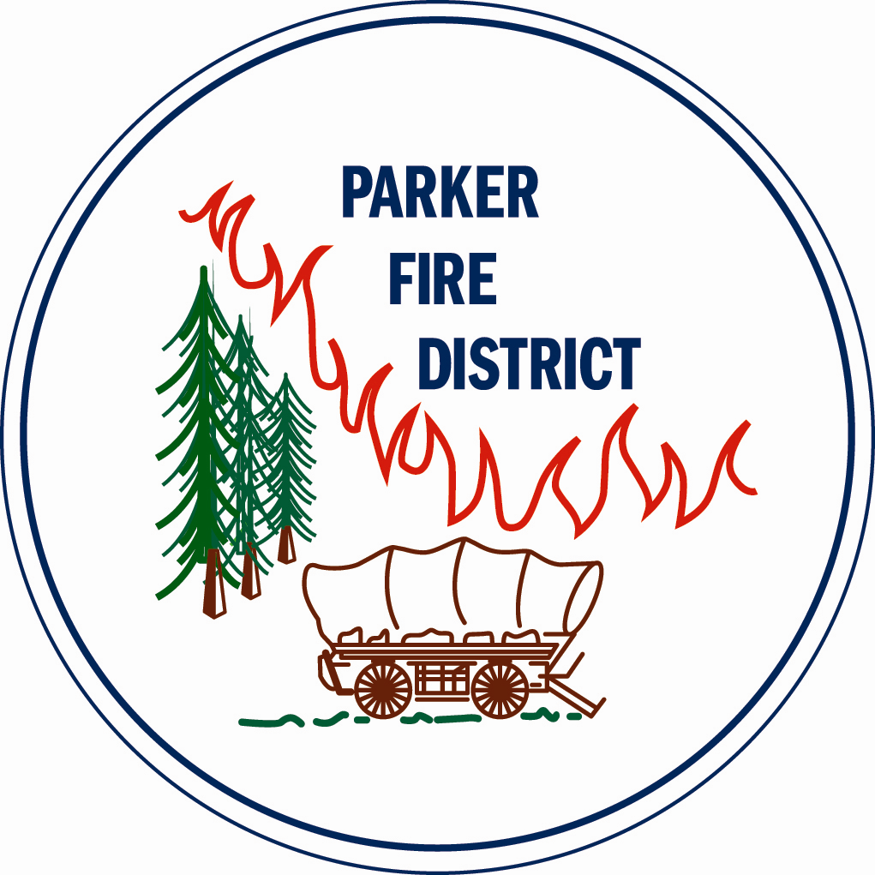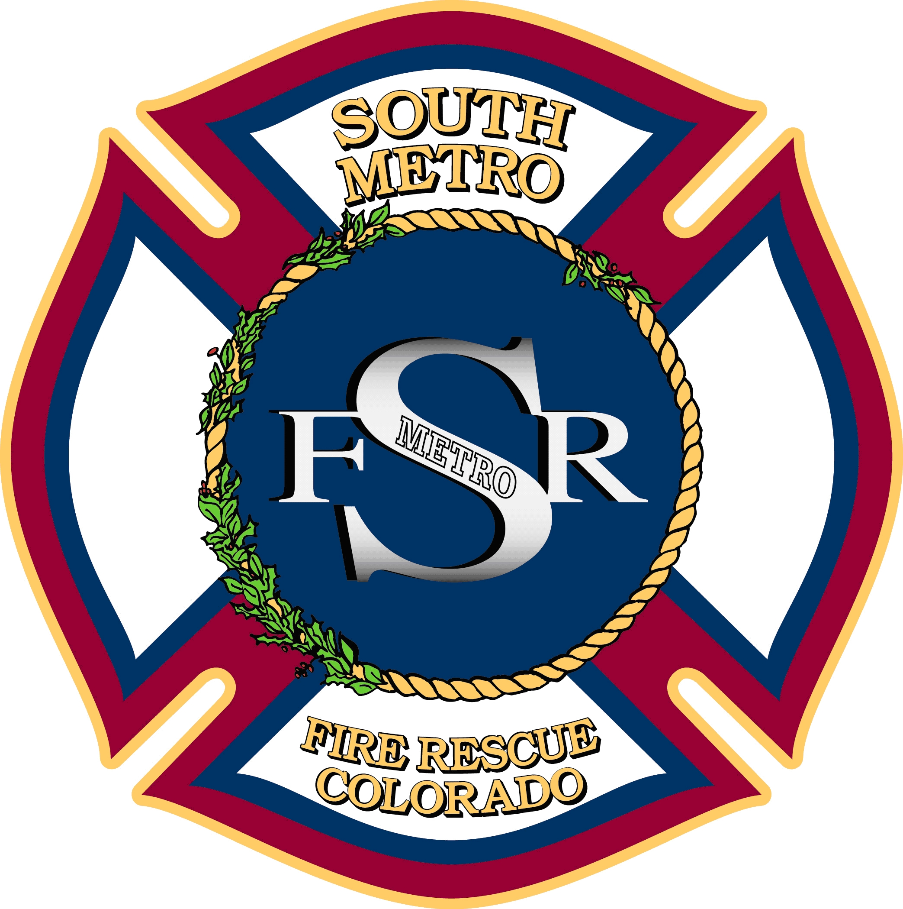

JOINT BOARD OF DIRECTORS SPECIAL MEETING

SOUTH METRO FIRE RESCUE AUTHORITY
PARKER FIRE DISTRICT
SOUTH METRO FIRE RESCUE
BOARD OF DIRECTORS

9195 East Mineral Avenue
Centennial, CO 80112

May 11, 2015
6:00 p.m.

MEETING CALL TO ORDER

ACTION ITEM
- Station 31 Construction Project

ADJOURNMENT

