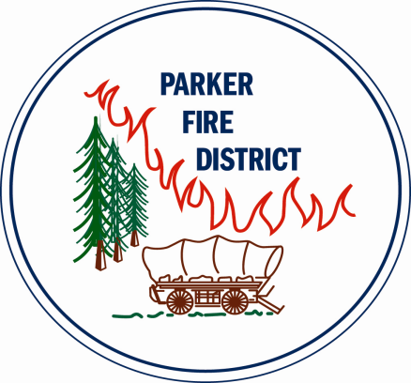
REVISED
NOTICE OF REGULAR MEETINGS
OF THE BOARD OF DIRECTORS
OF PARKER FIRE PROTECTION DISTRICT

NOTICE IS HERBY GIVEN that the Board of Directors of Parker Fire Protection District, of the Counties of Arapahoe and Douglas, State of Colorado, will hold its regularly scheduled District Board Meetings:

Fourth Monday of each month at approximately 5:30 p.m.
at
9195 E. Mineral Avenue, Centennial, CO

By: Order of the Board of Directors
Parker Fire Protection District
By: Secretary of the Board

The normal agenda for each month is as follows:

- Call to Order
- Public Comment
- Consent Agenda
- Action Items
- Information Items
- New Business
- Old Business
- Executive Session (upon motion)
- Next Meeting
- Adjournment

