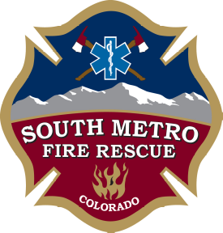

NOTICE

CHANGE OF MEETING LOCATION

SOUTH METRO FIRE RESCUE
BOARD OF DIRECTORS’ MEETING

The location of the January 17th Board of Directors’ Work Session
and Regular Meeting has been changed to:

17801 East Plaza Drive
Parker, CO 80134

