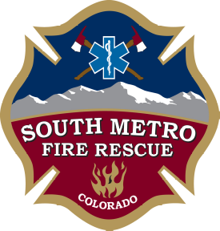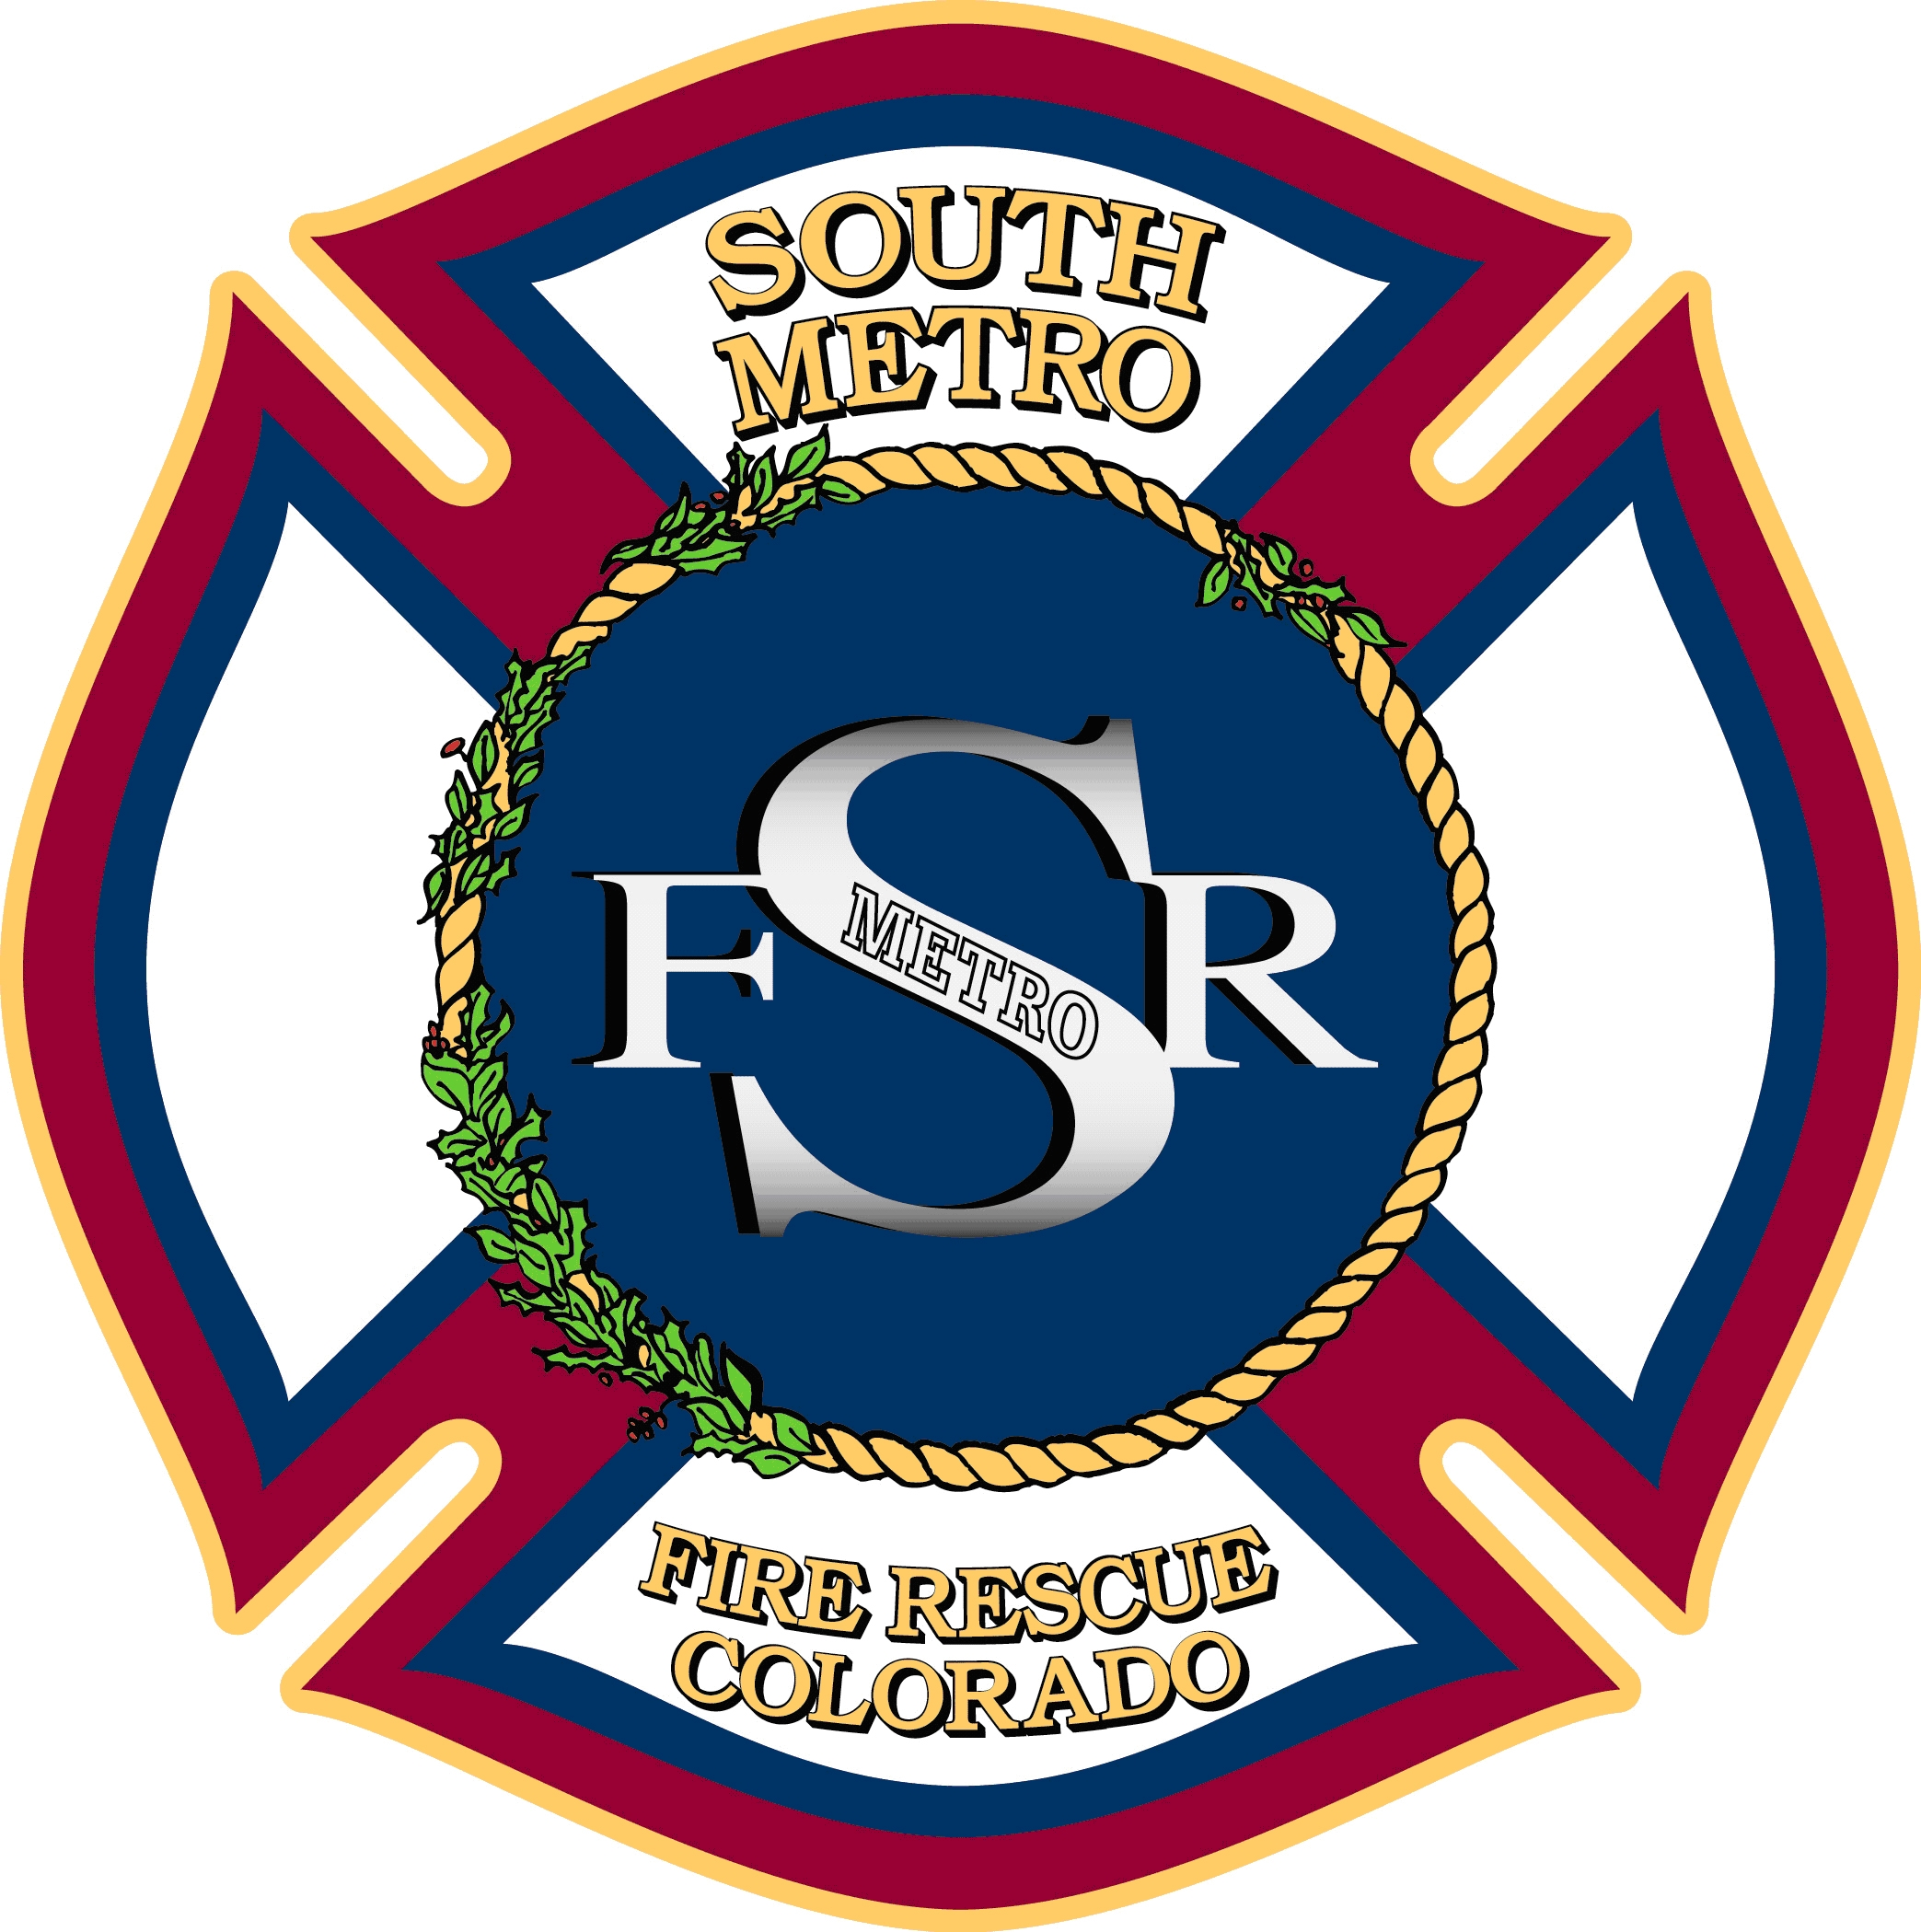

NOTICE

CHANGE OF MEETING DATE

SOUTH METRO FIRE RESCUE AUTHORITY
PARKER FIRE DISTRICT
SOUTH METRO FIRE RESCUE
BOARD OF DIRECTORS’ MEETINGS

9195 East Mineral Avenue
Centennial, CO 80112

The date of the August 24th Board of Directors’ Meetings has changed to August 17th.

