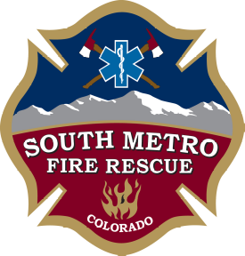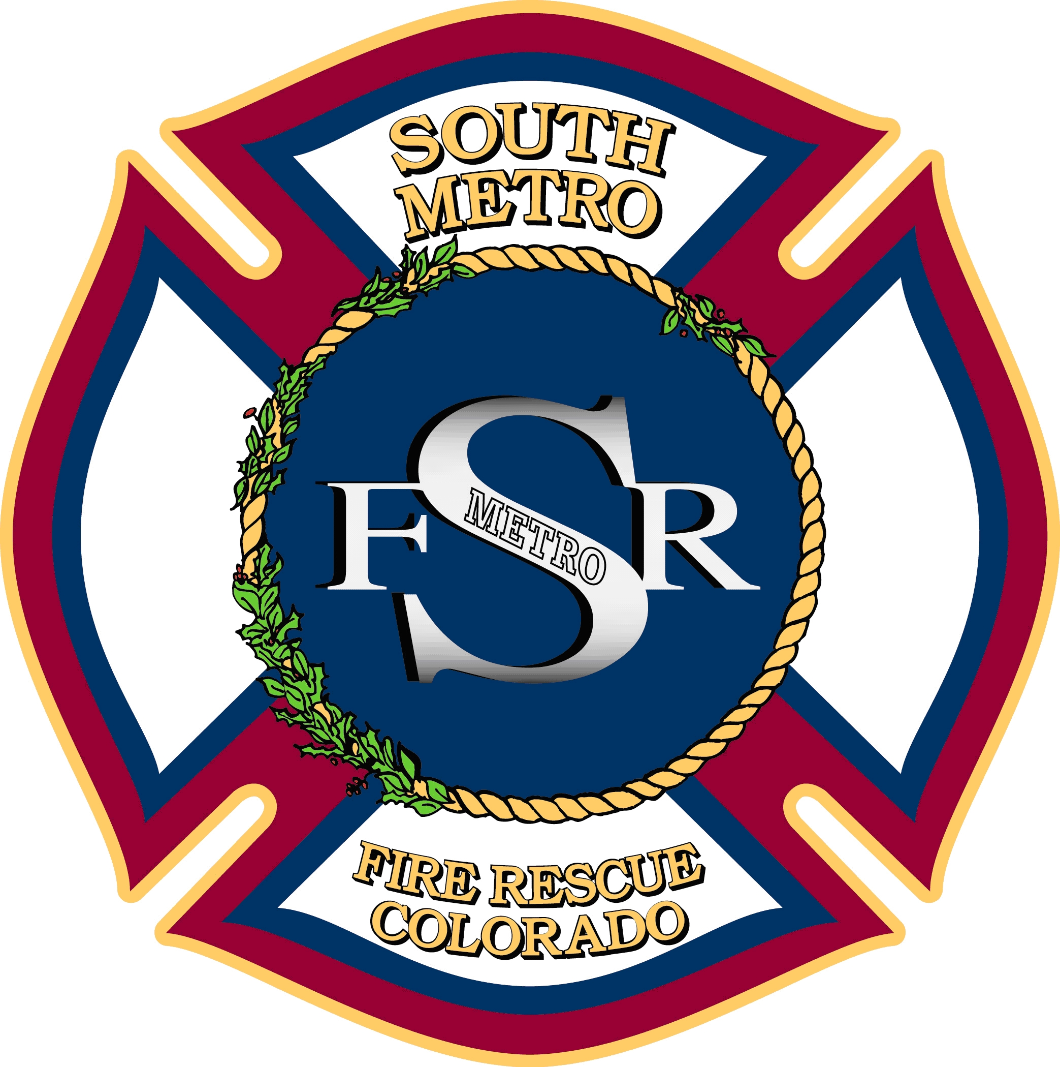

JOINT BOARD OF DIRECTORS WORK SESSION

SOUTH METRO FIRE RESCUE AUTHORITY
PARKER FIRE DISTRICT
SOUTH METRO FIRE RESCUE

9195 East Mineral Avenue
Centennial, CO 80112

July 7, 2015
6:00 p.m.

MEETING CALL TO ORDER

DISCUSSION
- Board succession planning for 2016
- Overview of the Strategic Plan

ADJOURNMENT

