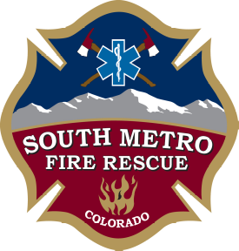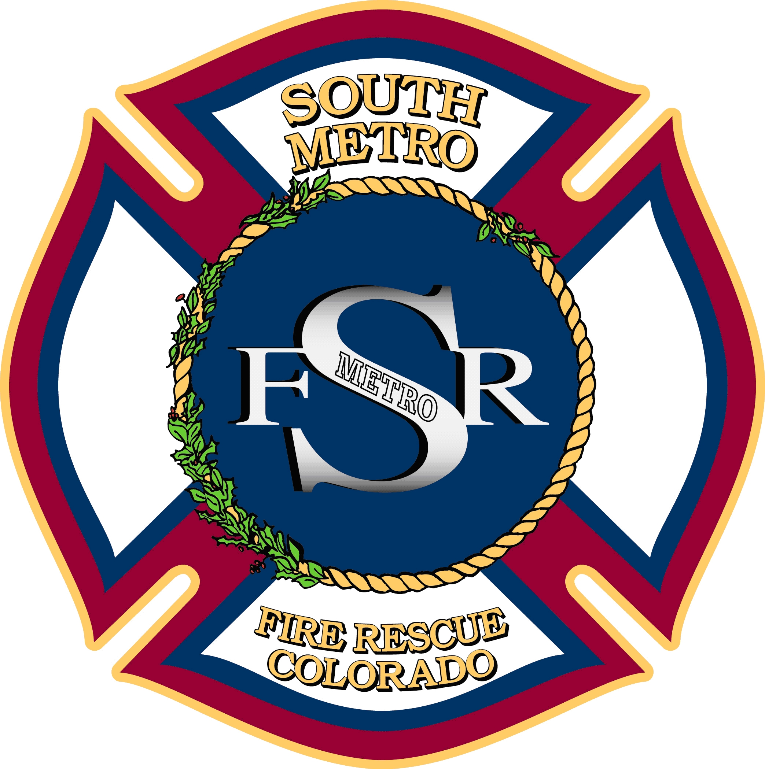

JOINT BOARD OF DIRECTORS SPECIAL MEETING

SOUTH METRO FIRE RESCUE AUTHORITY
PARKER FIRE DISTRICT
SOUTH METRO FIRE RESCUE
BOARD OF DIRECTORS

9195 East Mineral Avenue
Centennial, CO 80112

May 11, 2015
6:00 p.m.

MEETING CALL TO ORDER

ACTION ITEM
- Station 31 Construction Project

EXECUTIVE SESSION (If needed)
- Potential Executive Session pursuant to Section 24-6-104 (4)(b) and (e), C.R.S. for a conference with legal counsel to receive legal advice and to determine positions relative to matters that may be subject to negotiations, developing strategy for negotiations, and instructing negotiators, regarding the Station 31 design review application with Greenwood Village.

ADJOURNMENT

