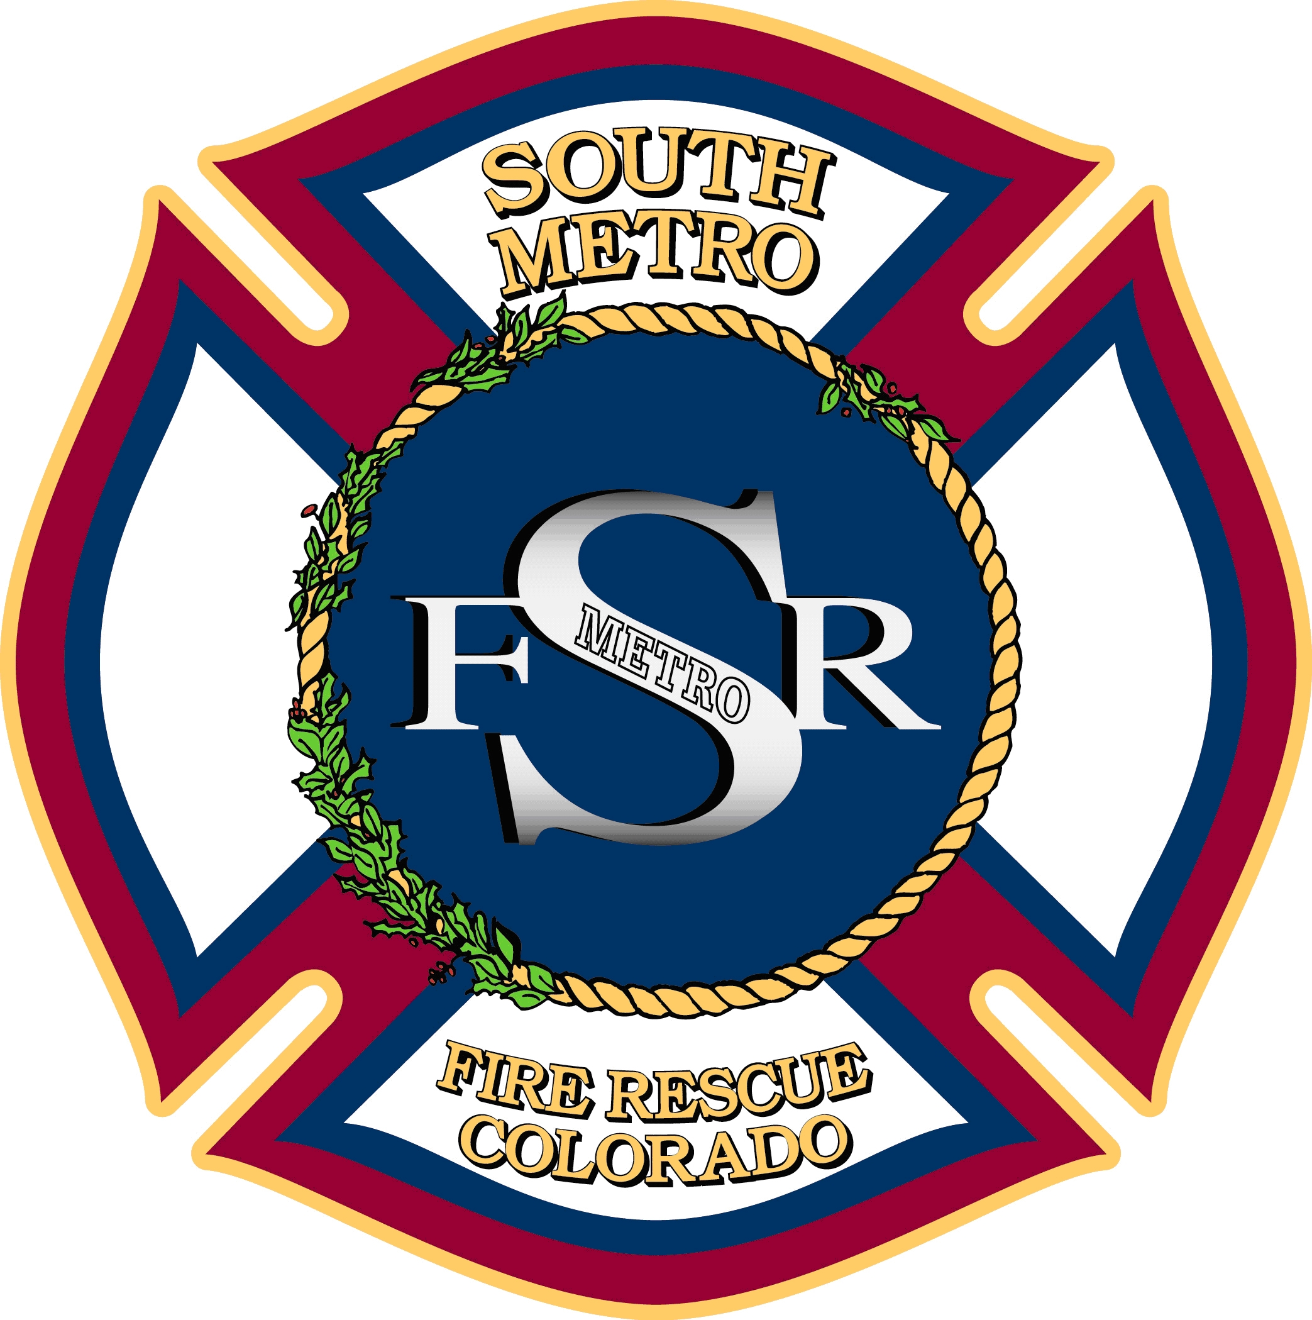

PARKER FIRE PROTECTION DISTRICT (PFPD)
SOUTH METRO FIRE RESCUE (SMFR)
SOUTH METRO FIRE RESCUE AUTHORITY
BOARD OF DIRECTORS
REGULAR MEETINGS
2015

January 26
February 23
March 23
April 27
May 26 —Moved to 4th Tuesday
June 22
July 27
August 17 – Moved to the 3rd Monday
September 30 – Moved to the 5th Wednesday
October 26
November 23
December 14 —Moved to 3rd Monday

All meetings are scheduled to be held
on the fourth Monday of every month
at
9195 East Mineral Avenue, Centennial, CO
Beginning with PFPD at 5:30 p.m.;
SMFR at 5:45 p.m.;
Followed by SMFR Authority at 6:00 p.m.
unless scheduled otherwise

