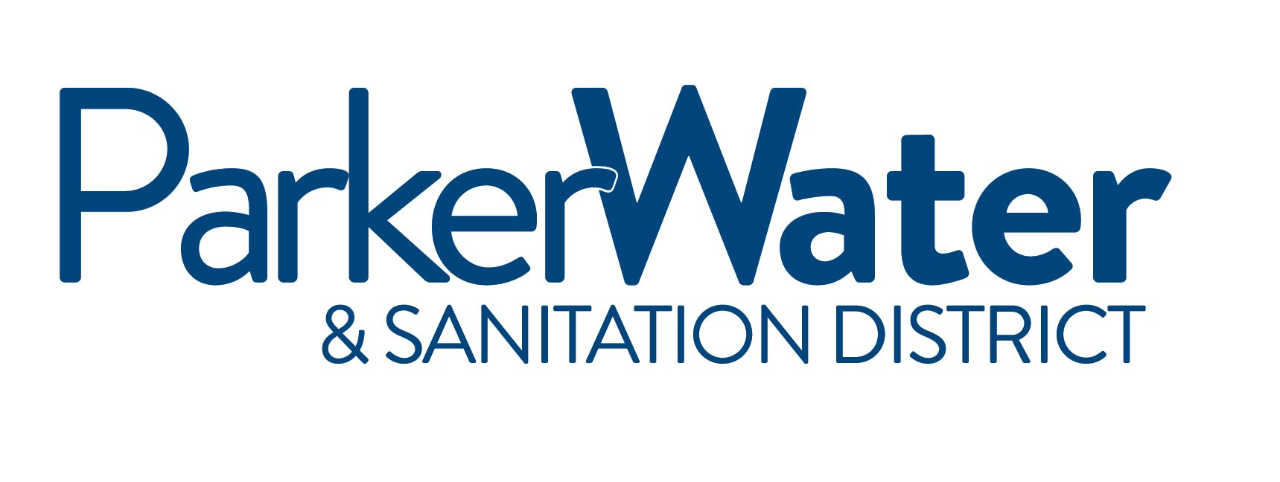

NOTICE IS HEREBY GIVEN
that the Board of Directors of the
PARKER WATER & SANITATION DISTRICT
of Douglas County, Colorado will hold a Special meeting, beginning at the

Parker Water & Sanitation District - North Water Reclamation Facility
18100 E. Woodman Drive, Parker, Colorado 80134

September 29, 2014
2:30PM

This Special Meeting will be held for the purpose of conducting a tour of the
District’s diversion structure and Rueter-Hess Reservoir.

