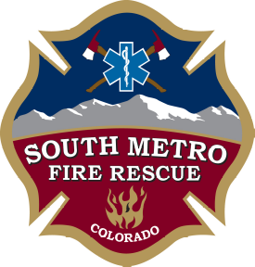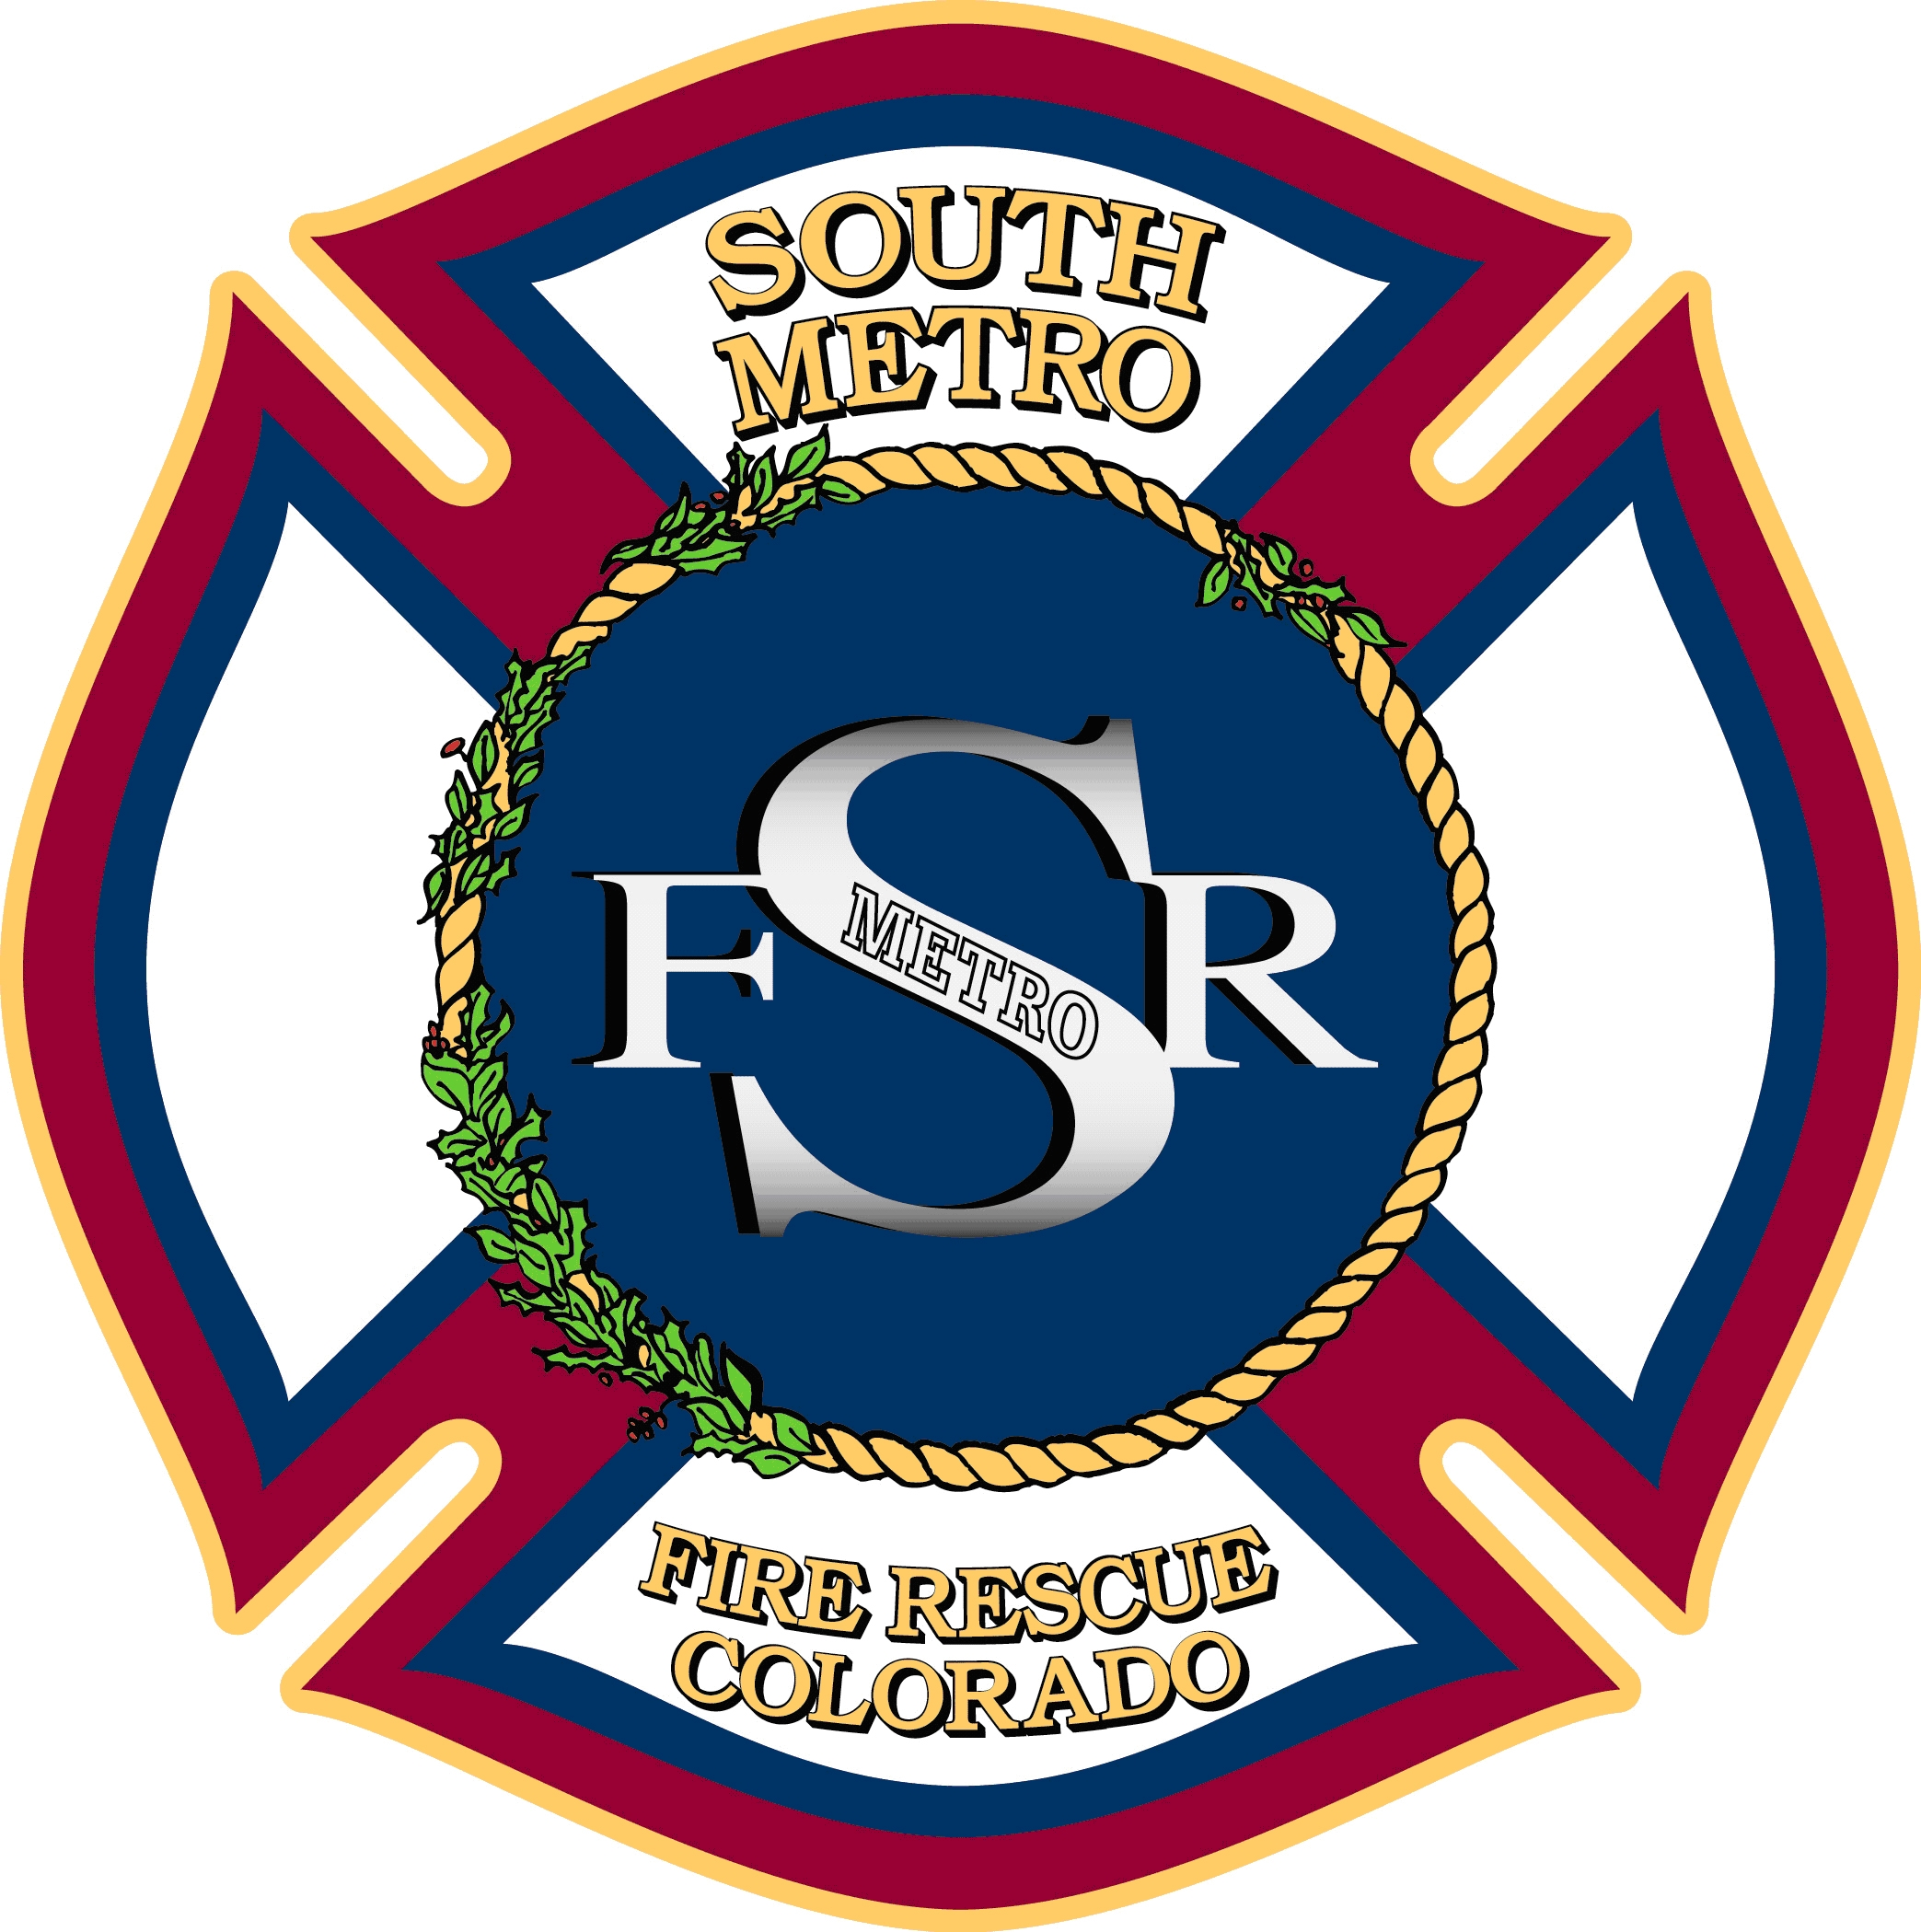

JOINT BOARD OF DIRECTORS WORK SESSION

SOUTH METRO FIRE RESCUE AUTHORITY
PARKER FIRE DISTRICT
SOUTH METRO FIRE RESCUE
BOARD OF DIRECTORS

October 27, 2014
following the SMFR Authority Board Meeting
9195 East Mineral Avenue
Centennial, Colorado

MEETING CALL TO ORDER

DISCUSSION
- 2015 Budget Work Session

ADJOURNMENT

